Fortnightly eFolio submission

Studio # 3 & 4

Name and Student Id: Nicolas Pallant 28785959

Self-Evaluation

|  |  |  |  |  |  |
| --- | --- | --- | --- | --- | --- |
| Need Help | Work in Progress | Pass | Credit | Distinction | High Distinction |

Task 3.1

Git Repository

https://github.com/Ryukawastaken/FIT5032-Internet-Apps-Dev

Task 3.2

Git Repository

https://github.com/Ryukawastaken/FIT5032-Internet-Apps-Dev

Task 4.1

Web Application

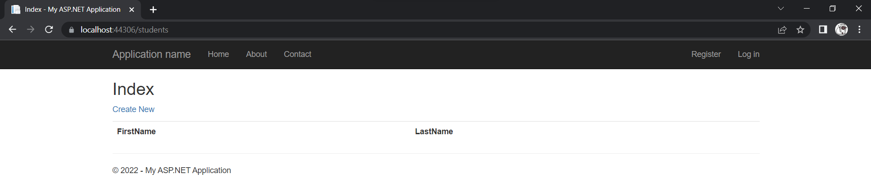

Query

Model View

Git Repository

https://github.com/Ryukawastaken/FIT5032-Internet-Apps-Dev

Task 4.2

Web Application

Context Code

Migration code

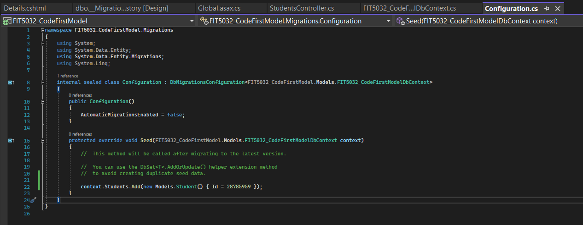

Git Repository

https://github.com/Ryukawastaken/FIT5032-Internet-Apps-Dev